**Beginner Course Notes**

**Before We Start**

Welcome to Reading Fencing Club, one of the largest fencing clubs in the UK. Whilst people have been trying to poke each other with swords pretty much since the Bronze Age, the roots of modern fencing stretch back to the early 18thCentury. It is also one of only four sports to have featured at every one of the modern Olympic Games since 1896.

Your course will be run using épée, however, fencers can compete with three different weapons –foil, épée, and sabre –and there's a brief description of each one below...

* [**Épée**](https://en.wikipedia.org/wiki/%C3%89p%C3%A9e)is what most people at RFC use, and indeed it is the most practised weapon in the sport today. Think of it as a duelling weapon – or rapier –with bouts in the old days being fought to first blood. The whole of the body is valid target, and as such the guard is slightly larger to protect the hand/wrist area from attack.
* [**Foil**](https://en.wikipedia.org/wiki/Foil_(fencing))was used in the old days (and, arguably, still today), as a practice weapon for those wanting to fence properly. The target area is restricted to the main torso of the body, with daft rules (called 'priority' or 'right of way') used to decide how points are awarded.
* [**Sabre**](https://en.wikipedia.org/wiki/Sabre_(fencing))is, admittedly, the coolest-looking of the three weapons. It is the only 'cutting' weapon in the sport and, most noticeably, has a swept-back guard and the blade designed for hitting with the edge rather than just the tip of the blade. Modern sabre is lightning quick – think of the game 'paper, scissors, stone', and you won't be far off.

Reading Fencing Club was founded in 1948, and as you'll have heard today has a flourishing membership base and is one of the best épée clubs in the country with Under 17, Under 20, Senior, and Veteran international honours.

Oh, and in case you're wondering, the other 3 sports are athletics, swimming, and artistic gymnastics.

**Lesson Structure**

Once everyone is kitted up, each lesson will begin with a warm-up and footwork session. (You can never have enough footwork practice!). The main part of the lesson will cover technical and/or tactical aspects of the sport and, at the end of the lesson, you'll have the chance to put what you've learnt into practice with a round-robin.

**Safety**

Some basic safety reminders for you...

* Always wear the correct clothing, i.e. mask, under-plastron, glove, jacket, long trousers, and comfortable trainers. Make sure that your protective equipment is in good conditions –for example, there are no holes in the clothing, stitching is intact, no rust or bad dent in the mask, and the mask has a working back-strap.
* Make sure that your opponent is ready to fence, and wearing the correct equipment, before you start battering the heck out of them.
* Do not lose your temper.
* Never turn your back on an opponent, or run into them, whilst fencing.
* Keep your non-sword arm out of the way.
* Do not use excessive force; hits on your opponent should be firm but light, with a slight bend in your blade.
* Obey the rules and the referee/coaches.

**The Grip**

There is an incredible variety of grips that can be used in fencing. The main two categories of grip are French and Pistol; both involve slightly different styles of play, but Olympic champions have used both.

Most people at the Club use pistol grips, however, for the duration of the course you will be using 'French' grips: a straight-ish grip contoured to the hand, with a metal 'pommel' on the end.

When holding your épée, make sure that your palm is slightly upwards – imagine that your thumb is the hour hand on a clock, and it should be positioned somewhere between one and two o'clock. Place your thumb near the guard on the top part of the handle, and then wrap the rest of your fingers loosely around the handle.

**Parts of the Epée**

Different parts of your weapon are useful for different things when fencing. They are labelled below:

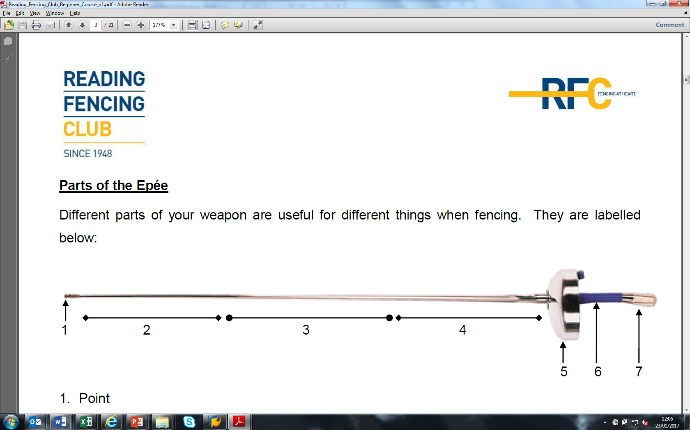1. Point

2. Foible

3. Mid

4. Forté

5. Guard

6. Grip

7. Pommel

**Weeks 1 & 2**

**The Basics**

**Principles of Epée**

Epée has perhaps best been described as “the art of making the fewest mistakes” (Éric Srecki). The main characteristics of épée fencing are that there are no restrictions on target area – you can hit your opponent from head to toe – and that there is no Right of Way; if two fencers hit simultaneously, both of them count as valid (known as a ‘double hit’).

**Salute**

Before starting, both fencers must salute each other (and the referee if one's present). This is done simply by raising your blade up toward them then down again – a bit like giving them a nod.

Once finished, fencers must salute each other again – and, again, the referee – before taking off their masks and then shaking hands (with the non-gloved hand).

**En Garde**

The en garde position forms the basis of your footwork, and good footwork is important for good fencing! Your feet should be at a right angle, hip-or shoulder-width apart. Your knees should be bent, with your bodyweight evenly distributed. Remember, there'll be a nutter in front of you, trying to hit you with a sword, so keep your eyes on them rather than your feet...

Your sword arm should be no more than an elbow's width away from your body, with your forearm more or less parallel to the floor. Keep your hand out to the side rather than in the middle (i.e. if you're right-handed, keep your hand over to the right) – this will provide better protection for you, and less options for your opponent. Try to keep your blade out to your sword-arm side, out of the way of your opponent, and remember that the point of your weapon should be no higher than your front shoulder. Oh, and relax your shoulders!

Keep your back hand out of the way; you can keep it up behind you 'Egyptian style' and use it as a counter-lever, however, you will risk looking like an idiot.

**Basic Footwork**

As you will no doubt be told many times over by your coaches, good footwork is essential. You should finish each step as it started: with your feet at right angles, hip-width apart, and with knees bent.

* **Stepping forwards**: lift your front toes and extend your leg, placing your heel on the ground before your toes; place your front foot down, and then lift (not drag) your back foot to close the distance. Ideally, the toe of the front foot should land at the same time as the back foot returns to the en garde position as it helps to make smaller, neater footwork.
* **Stepping backwards**: lift your back foot and extend it behind you; follow with your front foot, making sure that you step onto your heel first followed by toes second.

**The Lunge**

The lunge is a basic form of attack. Its power comes from your legs, so make sure your knees are – as they should be anyway – bent before you start.

A lot of fencing coaches will shout at their students “Arm first!!” – they’re only half correct. In reality, whilst your point should indeed move toward your target before your feet do, before even that happens you should *think*. If you’re absolutely sure you will score as a result of your lunge, either directly or indirectly, then great; if not, then don’t do it. So, really, it should be *brain* before arm, arm before feet.

As mentioned above, the first thing to happen for a lunge (after your brain has given you the go-ahead) is for your point to move toward the target, almost pulling your body behind it.

When it comes to the feet, the lunge starts as a step forward does: raise your front toes and extend your front leg. Instead of placing your foot on the heel as with a step, though, you extend into a longer stride by pushing off your back leg; your back arm should extend backwards at the same time to act as a counter-balance.

Throughout the movement, the body should remain upright with your weapon hand finishing no higher than shoulder-height. On completion of the lunge, your front knee should be above the instep, with a straight back leg; both feet should still be at right angles, flat on the floor, with your head and body upright.

After you have completed your lunge, you can recover one of two ways...

* **Recover backwards**: keep your back foot where it is. Push off your front leg and bend your back leg, using your rear arm as a counter-balance, to return to your original en garde position. This recovery is often used when your opponent tries to close distance on you.
* **Recover forwards**: keep your front still. Bring your back foot up to return to your original en garde position. This recovery is often used when your opponent moves out of the way.

You should be aware that there are two types of lunge – explosive, and accelerating – which can be used depending on the situation. The technique involved with both types of lunge remain exactly the same, it is only their speed that differs.

* **Explosive:** there is just one speed for explosive lunges – fast! Point first, lots of power from the legs; use an explosive lunge for more direct attacks, where speed is paramount for closing distance on your opponent.
* **Accelerating:** one of the more difficult footwork techniques to master; use an accelerating lunge for more complex attacks that involve preparations (covered later in the hand-out). After extending your arm, proceed with the lunge at half speed – this time is reserved for preparing an attack – and then, as you finish your preparation, fully extend your arm and accelerate your lunge to full speed to reach the target.

**The Stop-hit**

Epée is an opportunistic weapon. A good épéeist should always look to score a hit – without being hit themselves – at the earliest moment possible, and with the least amount of effort; the classic example of this is the counter-attack (also known as ‘stop hit’).

First, move your point out to the side – this will invite your opponent to attack, and also give you a better angle to hit them – and then place your point on their wrist by using your thumb and index finger.

Remember that it’s your *point* that scores the hit, not the side of the blade. Have only oneshot at the target before – regardless of whether or not you hit – stepping back out of range of your opponent’s attack where you may want to do a parry-riposte or, better, a hit in opposition (which we will come to later).

Extending your hand forwards is a bad idea when someone’s coming towards you and, if you miss, you’ll be too close to them with your blade caught in a bad position – allowing your opponent an easy hit. Using only your fingers helps as it’s a quicker movement and, if you miss, your guard and blade will be in an ideal position to pick up your opponent’s blade in a parry.

At this juncture any geeks might want to look up arguably the most famous martial artist of all time: Bruce Lee. Lee studied many martial arts and fighting styles but, crucially, studied fencing heavily and his own martial art, Jeet Kune Do, takes its stance, footwork and major strategic points from fencing. The latter of these, and in particular the stop hit – a key element of épée fencing – is essentially Jeet Kune Do’s namesake: the way of the intercepting fist. It is based on the principle that one can set up an opponent so that you can intercept them in their most vulnerable state – their attack.

**Parries (4, 6, 8) and Riposte**

Anyway, moving on. A ‘parry’is just a posh word for ‘block’. There’re several positions that you can use to parry, and several ways in which you can get there; the ones below are the most basic and also most used.

* **Lateral part of quarte:** keeping your point where it is (in line with your opponent), move your guard horizontally across from sixte to quarte. Keep your hand at the same height, with the pommel pushed away from the wrist, and make sure not to push your weapon too far from your body. The foible of the attacking blade should be trapped between the guard and forte of your weapon.
* **Circular parry of sixte:** move your point in a (clockwise) circular movement to catch the foible of your opponent’s weapon between the guard and forte of your own. You should finish in the same position as when you started, but with your opponent’s blade on the opposite (sixte) side of yours. The size of circle made by your point is less important – arguably the bigger the better – but, importantly, whilst making it you should only use your fingers and a little bit of wrist (not the whole of your arm!).
* **Semi-circular parry of octave:** move your point in an anti-clockwise direction (opposite to circular parry), making contact with your opponent’s blade and then pushing it to the side, so it’s no longer near your target area. To make it more effective, you might want to move your hand over to the right as well –this will give you more protection whilst also allowing an easier angle to riposte from.

On a technical note, when describing a parry its *type* is used first, and its *finishing position* second. For example, if you started in quarte you could do a “lateral parry of quarte”, a “circular parry of quarte”, or even a “semi-circular parry of septime”. You would rarely have cause to do any of these, but at least now you know the terminology… for reference and to help visualise, all 9 positions are shown in a diagram on page 11.

A ‘riposte’is an offensive action that follows after a parry has been made; the defender becomes the attacker. There are a couple of variations on how you can hit your opponent with a riposte, depending on the situation…

* **Direct:** where a hit is scored without passing under or over the opponent’s blade, i.e. in the straightest line possible to the target area.
* **Indirect:** after making a successful parry, your point finds its way to the target but not in a straight line, i.e. you move your point under or over their blade.
* **Attached:** where your blade keeps in contact with your opponents; after making a parry, slide your blade along your opponents to score a hit (always keeping contact between the two blades).
* **Detached:** where, after making a parry, your blade loses contact with that of your opponents, e.g. with an indirect riposte.

**Hitting in Opposition**

Really, in fencing you would only do a parry-riposte in the two, very silly, weapons of foil and sabre. As the first page explains, points in foil and sabre are awarded – or annulled, and in any case very often argued over – according to a system of ‘priority’ or ‘right of way’.

Under the system of priority a fencer would do a parry-riposte to not only hit their opponent but, perhaps more important than whether they hit on- or off-target, to show that it was their right of way at the time.

Epéeists are not constrained by such frivolous rules: if both fencers hit simultaneously – within 0.25 seconds of each other – then, almost all of the time, they both score a point.

(A point would only be annulled in épée under the same grouping of rules that apply across all three weapons, such as dimensions of the piste, unsportsmanlike conduct, cheating, etc.)

In épée, therefore, there is often a much more efficient way of attempting to hit your opponent: hitting ‘in opposition’. In doing this, the two movements of blocking out the opponent’s attack and extending your arm to hit them are combined into one, seamless, move. This saves time over a parry-riposte and is therefore also harder to defend against.

**Weeks 3, 4 and 5**

**Preparations, New Parries & Second Intention**

**Cross-over Steps**

We will not cover these in detail on the course, but they are worth noting. Cross-over steps cover slightly more distance – about 1.5x – than a normal step, and are used to cover distance quickly, either to close for an attack or to get out of the way of your opponent's.

* **Forwards:** starting with your rear foot, move it forwards, across the front of your body, and place it on the ground in front of your other foot (in the same position prior to movement). Lift your front foot, move it forwards, and place it on the ground (onto the heel first) so that you are back to the en garde position.
* **Backwards:** starting with your front foot, move it backwards, across the back of your body, and place it on the ground behind your other foot (in the same position prior to movement). Lift your back foot, move it backwards, and place it on the ground so that you return to your original en garde position.

**Balestra**

The balestra is a forward, jumping, movement that serves two purposes. Firstly, it is a quick way of gaining ground on your opponent and, secondly, acts as a preparation by intimidating/surprising your opponent, making them react.

Start of as you would a forward step, by raising your front toes. Extend your front leg, as with a step or lunge, and push off your back foot to gain extra distance. Both your feet should land at the same time, and you should finish as you started, on balance in the en garde position.

**Reprise**

This involves replacing your point but with a bit of extra footwork involved. For example, once you have completed a lunge, lift up your back foot and place it 10-15cms forwards from its original position, and push off your back leg into either another, smaller, lunge, or a flèche (see below).

**Flèche**

This is one of the hardest footwork techniques to master; when executed well, it is an excellent way to rapidly finish off your attack and score a magnificent hit on your bewildered opponent.

As with any attack, it should be *brain* before your hand, then hand before foot. In terms of footwork, again, your knees should be bent, and as you tilt your weight forwards slightly, push off your back leg to propel you forwards, and then drive it through in the direction of your target. You should, in theory, hit your opponent *before* your back leg lands on the floor.

If you hit your opponent *after* your back foot lands, or indeed you didn’t hit them at all, then it’s for one of three reasons: either your technique was insufficient – not enough ‘oomph’, normally; poor timing, for example your opponent was already moving out of the way, or was prepared; or that you were just too far away. Or an unhappy combination of the above.

From a technical point of view the energy of the movement should be aimed forwards, not upwards, and your body should remain upright, with your head level and eyes facing forwards.

After (hopefully) hitting your opponent, you should move around them: move to your sword-arm side – if you need to, this will allow a better opportunity to hit your opponent again – and then continue past.

N.B. If you miss, your opponent is allowed one parry and one riposte to hit you, even once you’ve passed them! The flèche should not be over-used, but is a useful move and should be done to its full effect every time.

**Engagement (and counter-engagement)**

There are four main types of engagement: simple, bind, envelopment, and croisé. The latter three will be covered later in your courses. A 'simple engagement' of the blade simply means taking control of the opponent’s foible with your own blade – principally the forte and guard – as a means of making a direct hit or in preparation.

Whenever attempting to engage your opponent’s blade, make sure that you use only your fingers and wrist movement, not the whole of your arm. The smaller the technique, the quicker it will be and therefore harder to defend against.

**Feints and Preparations**

If you can understand this statement then you’ll go far: “The art of fencing is knowing what your opponent wants to do, and then making them do what they *think* they want to do”.

When fencing at good distance, and against someone who knows what they’re doing, if you want to win then you’ll often be required to be sneaky, underhanded, devious and despicable. (This is what makes fencing fun). Pay attention to what your opponent’s doing, what they’re good/bad at, and draw a response by using a ‘preparation’– for example, a beat, pressure, froissement, coulé or feint – before hitting them somewhere else.

* **Beat:** one of the simplest preparations, the beat is a short, crisp striking movement against the opponent’s blade. The aim is to knock their blade aside (and provoke a reaction). Make sure to use only your wrist and fingers to move your blade, rather than your whole arm. The objective is one of subtlety and guile, not to bash your opponent’s weapon across the room – as such, it is a small movement, and your blade should stop where it makes contact with your opponent’s. Most often, the beat will be used in tandem with either a feint, a disengagement, or a cut-over.
* **Pressure:** with the blades engaged, simply pressure the mid-section of your opponent’s blade in a lateral motion. Use your fingers and wrist movement, keeping your hand and arm in the same position. The aim is to provoke a response from your opponent. A short, sharp pressure will provoke a more immediate reaction (similar to the beat), whereas a slower one will allow for more control of their blade. Most often, an effective pressure will provoke your opponent to counter-pressure, allowing you to attack with either a disengage or a cut-over.
* **Froissement:** can be translated into English as “rustle” (in terms of noise). The move involves making contact with your opponent’s blade at its foible, and then sliding your blade down toward their guard whilst exerting pressure at the same time. So, like a pressure but with movement on the blade.
* **Coulé:** is a posh term for what coaches often refer to as ‘taking’ or ‘engaging’ the opponent's blade. Control the foible of their blade between the forté and guard of your weapon, and then move it toward the target as necessary.
* **Feint:** is pretty much what it says on the tin. Often used immediately after an attack on the blade (i.e. one of the above), threaten your opponent's target with the point of your weapon in order to draw a response. Don't over-extend your feint and risk getting hit, and remember that you can feint at different targets such as wrist, chest, mask, leg, or even foot.

**Disengage (and counter-disengage)**

A disengage is the avoidance of your opponent's blade when they attempt to engage your own. Simply use your wrist and finger movement to move your point underneath your opponent’s blade, without touching it, and then back up again. Make the movement as small as possible: smaller movements are quicker and therefore make it harder for your opponent.

Whilst a disengage passes *underneath* your opponent's blade, a ‘cut-over’will pass *over*.

**Counter-time**

Counter-time is essentially the counter-attack of someone's counter-attack. This is used a lot by good épéeists; feint at your opponent to draw a counter-attack from them and, when they react, take their blade and hit them.

**Successive Parries**

When an opponent uses a compound attack against you, you will often be forced to make a number of parries to keep them from hitting you. Make sure that you don’t use the same parry too often, because a predictable fencer is easier to hit… and always remember that distance is also the best defence!

**Second Intention**

When you miss, or the person you’re trying to hit does something completely unexpected, use Second Intention. This system (and style) of fencing involves trying to hit your opponent once and then – no matter what – hitting them again for good measure.

In the event that you do hit your unwitting opponent twice, all you have to say is “Sorry” (you don’t have to mean it; it’s more out of politeness)… but at least you’ll have scored the point, which is much better than missing them on the first attempt and then feeling sorry for yourself after they hit you.

**Renewals (Remise, Reprise, Redouble)**

Sometimes your attack will fall short, in which case you will need to ‘renew’it. This can be done with one of three rather similar sounding techniques:

* **Remise:** simply replace the point (without any footwork required). You may have to angulate your blade in order to get a better shot at the target.
* **Reprise:** mentioned earlier, this involves replacing your point but with a bit of extra footwork involved.
* **Redouble:** similar to a remise, a redouble is a renewal of the attack, hitting in a different line. For example, if your attack to the quarte position of your opponent’s target area, you could redouble (to sixte).

**Repetitive Hitting**

This, in part, is covered under ‘Second Intention’. Second Intention is a little more planned (as the word ‘intention’ implies), whereas repetitive hitting is something that should be more instinctive.

The idea revolves around *automatically* renewing a hit on your opponent and has two main advantages: it will keep your opponent on the back foot and, more importantly, it’ll make you score more points!

Remember to say “sorry” if you do hit more than once…

**New parries (1, 2, 7, 9 [and also 3, 5 & 9])**

For your Grade 1 Assessment, you will only need to know the positions of sixte (6) and quarte (4). There are, however, nine positions in total and to help your fencing in general it will be useful to know the others…

* **Prime (1):** one of the hardest parries to get right under pressure, prime is a parry normally reserved for close quarters defence. From your en garde position in sixte, pronate your hand slightly and, as you make contact with the opponent’s blade, continue to lift your hand upwards in a diagonal movement. You should end up with your hand flexed at a right angle, positioned directly in front of your mask (roughly eye level). Try to keep your point in line with your opponent, and position your blade so that it is a small distance away from your body, in order to fully block the oncoming attack. To make a riposte, flex your wrist slightly and go for a direct hit, stepping in if necessary in order to close distance to the target.
* **Seconde (2):** another position that is primarily defensive, used regularly due to the strength of its final position and control over the opponent’s blade. From your en garde position in sixte, pronate your hand and move your point in a circular (anticlockwise) movement, trapping your opponent’s blade as you do. With control of their blade, move your guard slightly outwards (your elbow will also move out as a result). You should finish with your hand positioned slightly ahead and to the side of your body, making for a safe and solid position to make your hit. Angulate your point to go for a direct (attached) hit to the low section of your opponents target area, or hit indirectly.
* **Septime (7):** this position is on the non-sword arm side, with the point in a low line. It is rarely used, although can be effective in both attack (in a coulé, especially against left handers) and defence (in a bind or even a beat parry). From the sixte position, move your hand laterally across to the non-sword arm side (as with quarte) and drop lower your point so that it is still in line. You should finish with your foil pointing towards the target, with your opponent’s blade on the far side of yours. Make sure that it is your point that lowers, not your hand. Make a direct riposte (making sure that you keep control of your opponent’s blade) or an indirect (compound) one elsewhere on your opponents target area.
* **Neuvième (9):** probably the least used of all the hand positions in fencing it is, however, a nice one to know so that (when you’re good enough) you can show off once in a while… its position is the same as in prime, but with your hand placed slightly more in front. Make sure that you take the blade early and then, once in neuvième, make a quick and direct hit on your stunned and bewildered opponent.

The seven positions that we have covered so far are those used most frequently in épée and foil fencing, however, there are two more that you should also be aware of. They are…

* **Tierce (3):** this is the starting position in sabre and one of the main parries used with the weapon. Although it is seldom used in épée and foil fencing, tierce can be used in some (more advanced) compound attacks. From sixte, flex your wrist and turn your palm upwards (so that it is facing towards you).
* **Quinte (5):** only used in sabre fencing, this is a parry used to protect from lunging attacks to the head. From the sixte position, raise your hand upwards and tilt it inwards so that it finishes above and in front of your head, with the blade not parallel but sloping slightly upwards. If you have to do a parry of quinte in épée or foil, then something has gone terribly, terribly wrong.

All 9 positions are shown in the diagram below (from a right-hander’s perspective).

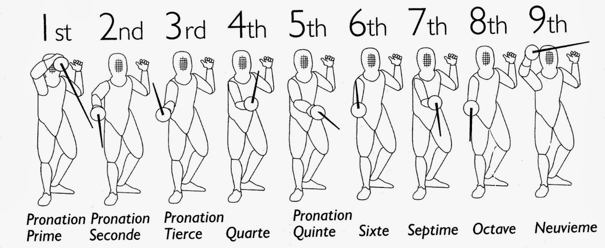

**Week 6**

**Dimensions of the Piste**

A fencing piste is 14 metres long, and 1.5 to 2.0 metres wide.

Two metres either side of the ***centre line*** are two ***en garde lines***, where fencing starts at the beginning of every fight and after each successful hit is scored.

Two metres from each end of the piste is a ***warning line***, and the ***warning zone*** in the last two metres of the piste is often coloured differently.

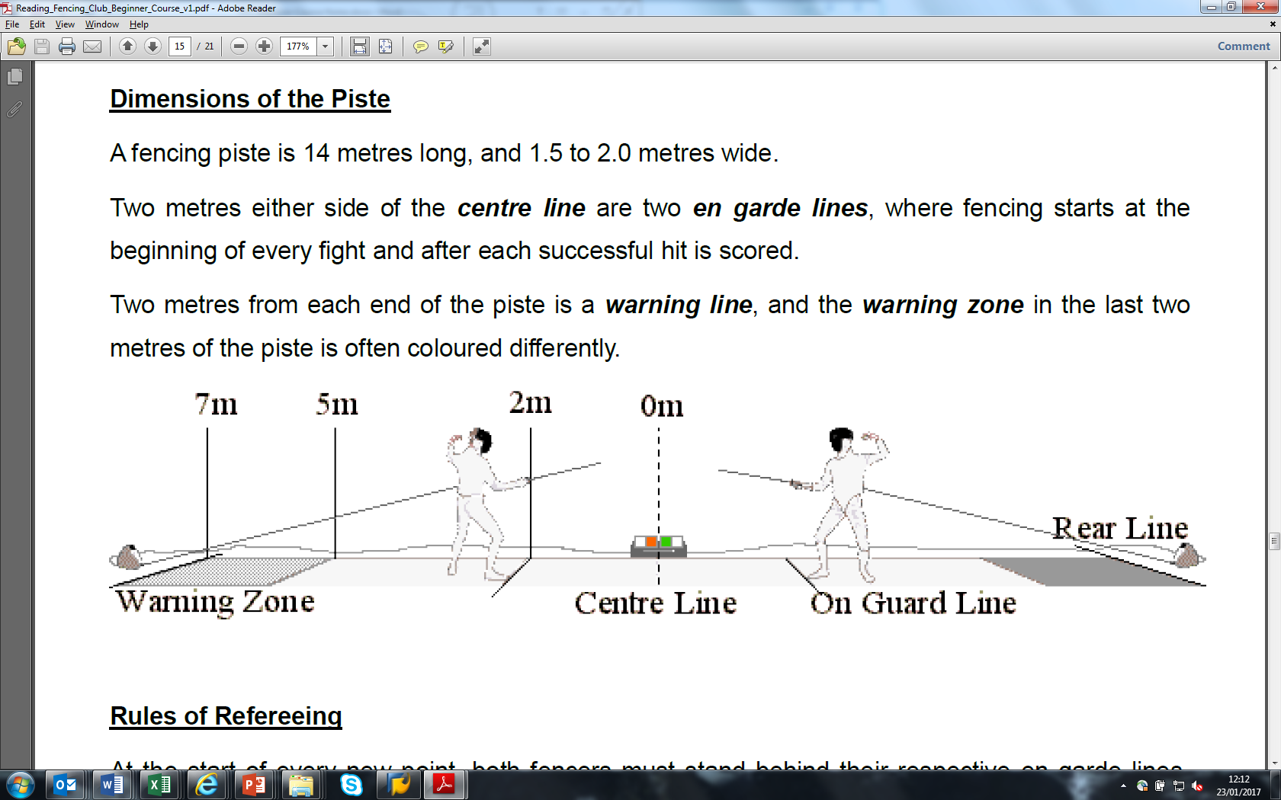

**Rules of Refereeing**

At the start of every new point, both fencers must stand behind their respective en garde lines. The referee stands on the outside of the piste, level with the centre line; these positions are taken at the beginning of every fight, and after a successful hit has been awarded. The referee’s commands are:

* *“En garde”* –to ask both fencers to come to their positions.
* *“Are you ready?” –*say *“no”* if you’re not.
* If there are no objections from either fencer at this point, the ref will say one of any of the following… *allez, fence, fight, play!*
* Whenever the bout needs to be stopped, the ref will say *“halt”!*

During free play, the ref must move in order to remain by the side of the fencers, whilst keeping a clear view to the scoring apparatus.

In the event of a non-valid hit being made, the ref will call ‘halt’ to stop play, and fencing will resume in the same place on the piste.

Stepping completely off your end of this piste will stop play, and a point will be awarded to your opponent.

Stepping off the side of the piste results in a stop in play, and when play resumes the offending fencer loses one metre in ground –if this results in the fencer crossing the back line, one point is awarded to the opponent. If this is done on purpose –to avoid being hit –the ref may award a yellow card.

The ref may give a fencer a ‘warning’ for small offences. A yellow card must be awarded if this offence is repeated, and two yellow cards will result in a red –giving one point to the opponent.

Please avoid… weapon failure (when fencing with electrics), the use of unreasonable force, failing to salute the opponent or referee.

**Competition Fencing**

Points win prizes! To win a fight you must get to the allocated maximum score before your opponent or, if time runs out, be the one with the most points. In épée, if for example you and your opponent are tied at 14-14 and there is a double hit, then you must replay the point until a single hit is scored (the same applies at 4-4 in a fight to 5).

In competitions, fights are often scored to 5 points in the first rounds (called ‘poules’), and then to 15 points in D.E. (or ‘Direct Elimination’) fights later on.

**Poule fights:** score 5 hits/3 minutes. The person who scores 5 hits first will win; if the 3 minute time limit is reached before either fencer has gotten to 5, the person who is leading will win.

**D.E.fights:**15 hits/9 minutes. Three times the fun of a poule fight… these are comprised of three 3-minute periods, with 1-minute rest periods in between (e.g. fence for 3 minutes, rest for 1 minute, fence a second period of 3 minutes, rest for 1 minute, and then a third, final, and nerve-racking final 3 minutes). Again, the first person to reach 15 points will win the fight and, in the event of time running out, the person leading on score will be victorious.

**Sudden death:** in the event of time running out and *both* fencers being tied on score, then the bout is decided with one final point. One person is given ‘priority’, normally by tossing a coin or spinning a pen or pencil, and then fencing resumes for a further minute –the person who scores the first hit will win or, if time runs out before a hit is scored, then the person with priority will win.

NB: time keeping in fencing is *not* continuous. The clock starts as soon as the referee tells the fencers to begin, and ends each time “halt” is called.

**Week 7**

**Grade 1 & Competition**

**Grade 1 Exam**

In week seven we will be doing a standard warm-up and footwork session, followed by an exam. It's really not that hard so don't panic, and if you want to have a look at the questions then the link can be found [here](http://www.britishfencing.com/uploads/files/epee_1-6_poster_no_photos.pdf).

**Competition**

After your Grade 1 we’ll split you into two teams, and will compete for chocolatey prizes!

(If you’ve any dietary requirements, please be sure to let us know in advance)

**Week 8**

**Distance & Experiments**

**Flicks**

We will give you a brief intro on how to flick and, more importantly, how to defend against them. A ‘flick’ is where you use the weight of the point, throwing it around an obstacle in order to hit. Flicks look cool, *but* only if you can do them properly.

Unless you’re a trained killer, going for flicks will often lead to one or more of the following: taking too long to wind up for the flick, exposing yourself (your hand in particular) and allowing your opponent to hit you; missing disastrously, allowing your opponent to hit you; standing there admiring your feeble attempt for too long, allowing your opponent to hit you; hitting your opponent with the flat of the blade instead of the point, causing pain.

So: flicking, don’t do it. Not for at least another 5 years!

**Foot hits**

If you go for a foot or leg shot on your opponent, try not to actually *look* at the target. Try to extrapolate where the target is – guess where the target is by knowing what else is known – for example, if you can see their hand, drop your point a little and your aim changes to leg; drop it further, and you go to foot.

The danger of looking at the target is that your whole body will drop when trying to score the hit, making it easier for your opponent to counter-attack, and making it harder for you to recover to a safe distance out of trouble.

**Distance**

By this stage in your brief but glittering fencing career, you’ll no doubt have had coaches yell at you numerous times for being too close to your opponent. Good footwork and good distance is essential to good fencing!

* **Keeping Distance**

There’s a saying that “distance is the best defence”; if you’re fencing anyone that knows what they’re doing, and you fall asleep on the spot, then they’ll hit you (with a ‘one tempo’ attack – explained below). Also, remember that even if you have scored a hit, your opponent has 0.25s to score a hit themselves for a ‘double’. Don’t give them the chance, get out of the way!

Always stay sharp and at a good distance; if they can’t reach you, they can’t hit you!

* **Controlling Distance**

Keeping distance is the most basic element of footwork. ‘Controlling’ distance is the next step; doing so will allow you to manoeuvre your opponent on the piste, to the distance and in the direction that you want them to be in. Controlling where your opponent is on the piste will make it easier for you to score a hit. Remember, it’s easier to reach the target if your opponent is moving toward you, or in the process of changing direction.

* **Tempo Distance**

Fencing is so important that it has its own time, called ‘fencing time’(or ‘tempo’). Consider that time and distance are linked: the further away your opponent is, the longer it’ll take to hit them; with this in mind, in a fight there is what’s called ‘one tempo’and ‘two tempo’ distance. (“Tempo” just means “time”).

One tempo distance is where you can hit your opponent in one move, for example with a direct lunge or flèche; two tempo distance is where the opponent is slightly further away, and you need two (or more) movements to reach the target.

If you or your opponent is caught napping during a fight, there may be an opportunity to score a quick point using a one tempo attack. If, however, they are too far away then you’ll need to do what’s called a two-tempo attack: drawing out your opponent with the first action, before hitting them with a second. (See also ‘Second Intention’). So when you’re fencing, before anything happens be aware of the distance between you and them: can you hit them in one move; can they hit you in one move; do you need to draw them out before attacking?

* **L’Aspirateur**

(French for the word ‘Hoover’). In fencing, as in normal life, if someone tries to hit you then your automatic reaction is to want to hit them back. This basic instinct can be turned to your advantage: on the recovering from an attack, if you go back to a safe distance whilst leaving your blade in absence, the bulk of your target will be exposed and more often than not the temptation will be too much for your opponent and they’ll likely try and attack you… providing that you’re ready for it, and at a safe distance, you can use your absence of blade to angulate a stop-hit to their wrist and then step out of the way again (you may need to come up with a parry afterwards just to make sure you’re safe).

**And Some Experiments**

If we have time at the end of the lesson, during your round robin we will also do some experiments. These are aimed at showing you the ad- and disadvantages of different aspects in a fight; such as…

* Position on the piste: your end vs. theirs
* Position of your point: point in line vs. absence of blade
* Aggressive vs. defensive
* Hits only to body vs. hits to ancillary targets (hand, leg, foot, mask)

**Week 9**

**Sport Psychology**

“Most games are lost, not won” ([Casey Stengel](https://en.wikipedia.org/wiki/Casey_Stengel))… it doesn’t matter who you are, what your ability is, or how long you’ve been fencing – psychology is massively important in fencing. In fact, if you just Google “sport psychology” you’ll come up with over 21 million results; do a search for the same on Amazon and there’re well over 7,000 books dedicated to the subject.

Below are just a few practical bits of advice that should help you in both training and competition. In your lesson we will talk about a few of these points and even do some experiments ~~on~~ *with* you…

**Mistakes**

We say early on in the course that épée is “the art of making the fewest mistakes” – this from [Éric Srecki](https://en.wikipedia.org/wiki/%C3%89ric_Srecki), a French fencer who medalled at 4 successive Olympic Games (so, fairly well qualified to comment).

As he says, fencing is about making fewer mistakes than your opponent, and the *only* thing that defines a mistake is your letting them score a point.

People miss. All the time. But missing an opponent isn’t necessarily a mistake; it’s only a mistake if you stand still and gawp and let your opponent score. Instead, renew the attack. Or get out of the way. Or both.

It sounds simple, but all you have to do to win is not let them hit you… if you have that in your mind on the piste – that you’re not going to give away any silly points – then it will serve you well; you’re distance will be better, and your mind clearer.

**Street Epée**

Obviously your coaches want you to fence elegantly, with balance, poise, control and finesse… however, we don’t care that much.

The sayings “it’s not pretty, but it counts”, and “winning ugly” both come to mind; it doesn’t matter how you get the hit, or if what you meant to do didn’t quite work out how you wanted it to: the most important thing is that you don’t get hit yourself.

Far too often, fencers make what they perceive to be a mistake – or even a hit – when in fact nothing has happened, they’ve stopped (quite often looking at the scoring box), their opponent hasn’t, and the referee definitely hasn’t yet called “halt”.

Don’t stop and get hit by your opponent – you’ll look like an imbecile. Remember: no mistakes!

**The Law of Dominant Thought**

Have you ever been in a situation where your dominant thought takes over and produces what you are most afraid of? We’ve all been victims of this, with examples like “Don’t miss this penalty” in football; “Don’t pocket the white” in a game of snooker or pool; “Don’t miss the put” in golf; “Don’t miss this serve” in tennis… and so on.

In fencing, the all-too-common scenario we come across can be found in the heat of an important match – maybe even the final of a competition – with the score tied at 14-14 and then that thought creeps into your head: “Don’t lose this next hit”.

In psychology, the law of dominant thought is based on the fact that your actions follow your thoughts and images*.

It sounds a bit ‘Jedi’ but, if your thoughts start to get the better of you: stop. Take control of your thinking, even your feelings. So, instead of thinking “Don’t lose this next hit”, think “I’m going to score this next hit”. This is intrinsically linked to the idea of ‘pressure’ – see below.

*Hence why some athletes use a technique referred to as ‘Visualisation’. The idea is that imagining a future scenario in your mind of what you *want* to happen reinforces this law of dominant thought in a positive way, and can therefore be conducive to success.

**Under Pressure**

What is ‘pressure’? Trick question; it doesn’t exist.

One of the most widely-used definitions of ‘pressure’, in the context we’re interested in anyway, is from Baumeister (1984) who describes it as “any factor or combination of factors that increases the importance of performing well on a particular occasion”.

Pressure exists in your head, and in your head alone. You can’t buy pressure online, or walk into a shop and pick up a can of pressure off of the shelves. Pressure is self-made; more accurately, it is self-inflicted.

Continuing in the vein of gratuitous use of quotes, pressure is “nothing more than the shadow of great opportunity” ([Michael Johnson](https://en.wikipedia.org/wiki/Michael_Johnson_(sprinter))).

Quite often sport psychologists and coaches will talk about “managing pressure”; this makes the mistake of assuming that it exists in the first place. It doesn’t exist, so by extension anyone who thinks they can *manage* it is talking nonsense.

So, the best thing to do is not to create pressure in the first place. However, if you do, it stands reason that if you can ‘create’ pressure you can also ‘deconstruct’ it. Remind yourself that there’s no pressure, stop thinking about the outcome of your actions, and start thinking about the actions themselves.

**‘One Hit’ Mentality and ‘Easy’ Fights**

Following on from the above, it doesn’t matter if the final score is 1-0 or 15-14, it only takes one hit to win a fight. Be patient. Think about the next hit and the next hit alone.

On that note, how would you define an ‘easy’ fight?

The answer is itself easy: it is the fight you’ve just won. It’s not uncommon for people to think about who they’re fencing next, whilst they’re still in the midst of fighting their *current* opponent.

A certain level of confidence is good, but don’t underestimate your opponent; thinking about who you’ve got to fence next will detract from your focus.

**What’s in a Name?**

Nothing is – it’s just a name.

At the other end of the arrogance spectrum, if you walk onto the piste thinking you’re probably going to lose… well, you probably will. Too often fencers – of all levels of experience – will lose before they have even stepped on the piste.

It doesn’t matter if you’re fencing a beginner or the reigning Olympic champion, you still need to beat ’em.

If they have ‘GBR’ on their back, it doesn’t matter – it may stand for ‘Great Brighton’ or ‘Gets Beaten Regularly’. Either way, make life awkward for your opponent. Fight for every hit.

**Losing, Learning… and Practise**

Gratuitous quotes by famous Michael’s continue… basketball legend [Michael Jordan](https://en.wikipedia.org/wiki/Michael_Jordan) said: “I've missed more than 9,000 shots in my career. I've lost almost 300 games. 26 times, I've been trusted to take the game-winning shot and missed. I've failed over and over and over again in my life. And that is why I succeed”.

Sorry to say it, but you will not win every fight. In fact when you are new to the sport, you’ll lose loads. Hard sell but it happens; get over it.

There is, however, a difference between ‘losing’ and ‘being beaten’. Neither are great admittedly, although ‘losing’ implies that you really ought to have won but didn’t. (Perhaps you crumbled under the pressure!).

Again, it’s important to think about the process and not the outcome. If you’re fencing someone much more experienced, as above, make it difficult for them. The Club offers you a great opportunity to learn so, after the fight, as your opponent for tips on how to improve.

Arguably more importantly, once you have identified areas for improvement… improve them! People have a natural tendency to practise only the things that they enjoy. And they tend to enjoy something because they’re good at it.

This approach will limit your progress. Use feedback from other fencers and your own reflections to improve the areas that *need* improving – get lessons where necessary – and this will help the overall quality of your fencing.

(As an aside, speaking of basketball. And [urban] legends. Urban legend has it that a Canadian P.E. teacher, Dr. James Naismith, invented the sport; a keen fencer, it is said that he created the game as a distraction for boys who weren’t bright enough to do fencing).

**Keep Calm and Carry On**

“Keep the fire in your heart, and the ice in your head” (Al B.)… no matter where you are, who you’re fencing, what the score is or how much you want to win, you should never, ever, lose your temper. A very common mistake when things aren’t going your way is to just “do it faster”. Don’t. All you’ll achieve is losing quicker.

Instead, keep a clear mind and just focus on winning the next point (i.e. making no mistakes) and you’ll fair a lot better. Plus, people who hit hard tend to have fewer friends.

**Week 10**

**Introduction to Club Fencing**

***Please note:*** *whilst not mandatory, in order to fully participate in this lesson, you will need to have your own breeches. The course coaches will give you information on purchasing equipment with plenty of notice.*

‘Electric’fencing is the norm nowadays. It involves a ***scoring box*** (usually referred to simply as “*box*”), situated by the centreline of the piste, which is connected to two ***spools*** at either end by what are called ***ground wires/leads***.

Each spool will have a socket, into which the fencer will plug their ***bodywire*** and then attach it to a clip on their jacket – the other end of the bodywire, which is worn underneath the fencing jacket, will plug into the socket of an electric weapon.

Fencers “test guards” before each fight – hitting your opponent’s guard once – to make sure that no scoring lights come up on the box.

Electric fencing is simple for the most part, with just two fencers and a referee. During play, any hits registered by either fencer will cause the box to beep and show some pretty lights, signalling the referee to call “halt”; the side on which the light appears is the same side by which it was scored.

In épée competitions, it is not uncommon for there to be ***floor judges***, because if the weapon hits the floor it will register a coloured light which may not be valid.

To eliminate this, and usually at competitions, fencers will sometimes play on what is called an ***electric/metallic piste***, which is hard-wired to the box and will eliminate most floor hits by earthing them out.

**Glossary**

**Prime, seconde, tierce, quarte, quinte, sixte, septime, octave, neuvieme:** positions in fencing.

**Absence of blade:** when the blades are not touching; opposite of engagement.

**Attaque au fer:** an attack that is prepared by deflecting the opponent's blade, e.g. beat, froissement, pressure.

**Balestra:** a forward hop or jump, typically followed by a lunge or flèche.

**Beat:** an attempt to knock the opponent's blade aside or out of line by using one's foible or middle against the opponent's foible.

**Bind:** an action in which the opponent's blade is forced into the diagonally opposite line.

**Broken time:** a sudden change in the tempo of one fencer's actions, used to fool the opponent into responding at the wrong time.

**Corps-à-corps:** physical contact between the two fencers during a match.

**Counter-attack (or “stop hit”):** an attack made against the right-of-way, or in response to the opponent's attack.

**Counter-disengage:** a disengage in the opposite direction, to deceive the counter-parry.

**Counter-parry:** a parry made in the opposite line to the attack; i.e. the defender first comes around to the opposite side of the opponent's blade.

**Counter-riposte:** an attack that follows a parry of the opponent's riposte.

**Counter-time:** an attack that responds to the opponent's counter-attack, typically a riposte following the parry of the counter-attack.

**Coulé:** an attack or feint that slides along the opponent's blade.

**Croisé (or semi-bind):** an action in which the opponent's blade is forced into the high or line of the same side.

**Cut-over (or coupé):** an attack or deception that passes over the opponent's tip.

**Derobement:** deception of the attack au fer or prise de fer.

**Direct:** an attack or riposte that finishes in the same line in which it was formed, with no feints out of that line.

**Disengage:** a circular movement of the blade that deceives the opponent's parry, removes the blades from engagement, or changes the line of engagement.

**Displacement:** moving the target to avoid an attack (i.e. dodging!).

**Double (-hit):** when two fencers hit each other at the same time (in épée, within 0.25s).

**Doublé:** an attack or riposte that describes a complete circle around the opponent's blade, and finishes in the opposite line.

**Engagement:** when the blades are in contact with each other, e.g. during a parry, attack au fer, prise de fer, or coulé.

**Envelopment:** an engagement that sweeps the opponent's blade through a full circle.

**Feint:** attacking into one line with the intention of switching to another line before the attack is completed.

**(Fencing) Time:** the time required to complete a single, simple fencing action.

**Finta in tempo:** lit. "feint in time"; a feint of counter-attack that draws a counter-time parry, which is deceived.

**Flèche:** lit. “arrow” in French, a short-to mid-ranged running style attack.

**Flick:** or “*coup lancé*” in French, an attack using the weight of the point to hit around an obstacle.

**Forte:** the lower, stronger part of the blade.

**Froissement:** an attack that displaces the opponent's blade by a strong grazing action.

**In Quartata:** an attack made with a quarter turn to the inside, concealing the front but exposing the back.

**In Time:** when a stop-hit arrives at least one fencing time before the original attack.

**Indirect:** an attack or riposte that finishes in the opposite line to which it was formed, by means of a disengage or coupé.

**Insistence:** forcing an attack through the parry.

**Invitation:** a line that is intentionally left open to encourage the opponent to attack.

**Line:** the main direction of an attack (e.g. high/low, inside/outside), often equated to the parry that must be made to deflect the attack; also point in line.

**Mal-parry:** a parry that fails to prevent the attack from landing.

**Middle:** the middle section of the blade, between the foible and forte.

**Parry:** using the forte of your blade to block an incoming attack.

**Passé:** the act of moving past the opponent.

**Phrase:** a set of related actions and reactions in a fencing conversation.

**Plaqué:** a point attack that lands flat.

**Point in line:** or just "line"; an extended arm and blade that threatens the opponent.

**Preparation:** the initial phase of an attack (before right-of-way is established).

**Presentation:** offering your blade to your opponent for them to engage it.

**Pressure:** an attempt to push the opponent's blade aside or out of line.

**Prise de Fer:** also "taking the blade"; an engagement of the blades that forces the opponent's weapon into a new line, e.g. a bind, croisé, envelopment, opposition.

**Redouble(ment):** a new action that follows an attack that missed or was parried.

**Remise:** immediate replacement of an attack that missed or was parried, without withdrawing the arm.

**Reprise:** renewal of an attack that missed or was parried, after a return to en garde.

**Riposte:** hitting your opponent after parrying their attack.

**Second Intention:** a false action used to draw a response from the opponent, which will open the opportunity for the intended action that follows, e.g. a counter-riposte.

**Simple:** an attack (or riposte) that involves no feints. *Or* someone who fences sabre.

**Simultaneous:** (foil and sabre) when two fencers hit each other at the same time, with neither having established priority*.*